|  |
| --- |
| NAME: Ayush Vinod Upadhyay  ROLL NO: I025  SAP ID: 60003220131  BRANCH: Information Technology  BATCH: 1 |

1. WAP to find value of y using recursive function, where y=x^n .

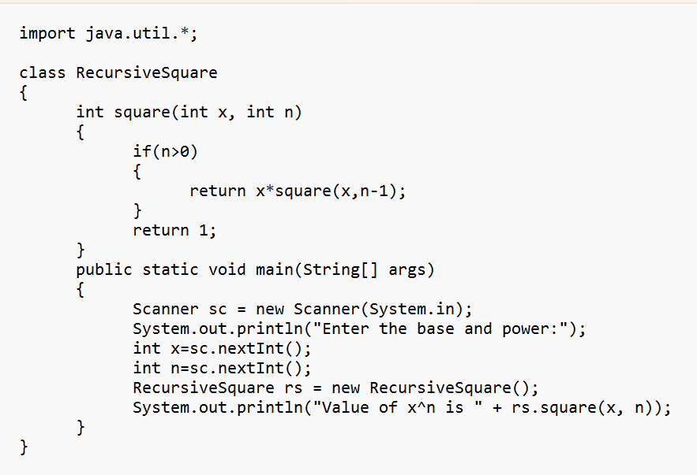

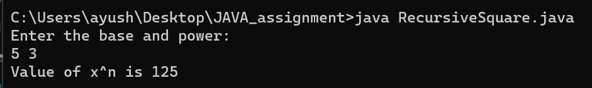

2. WAP to display area of square and rectangle using the concept of ***overloaded*functions.**

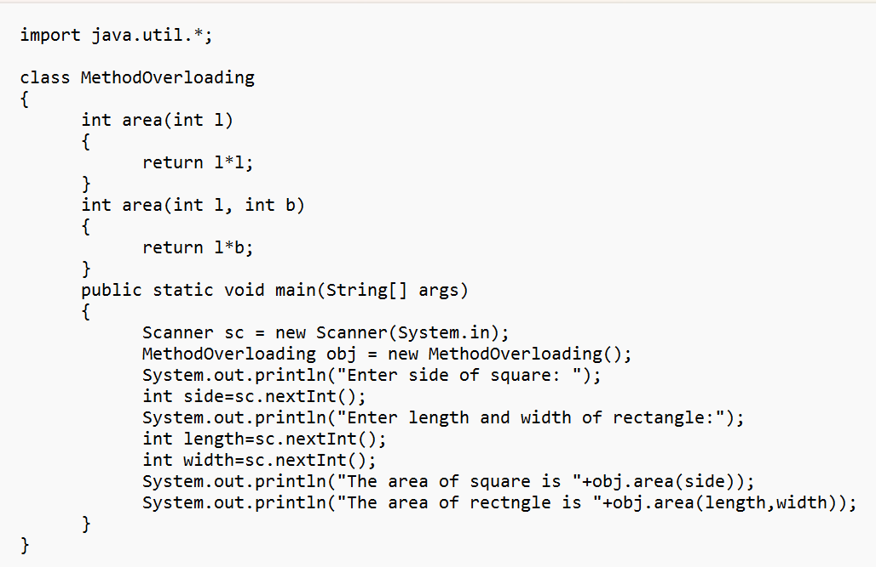

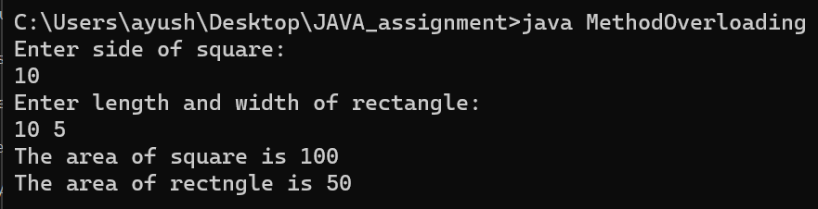

3. WAP to perform mathematical operations on 2 complex numbers by passing and returning object as argument.

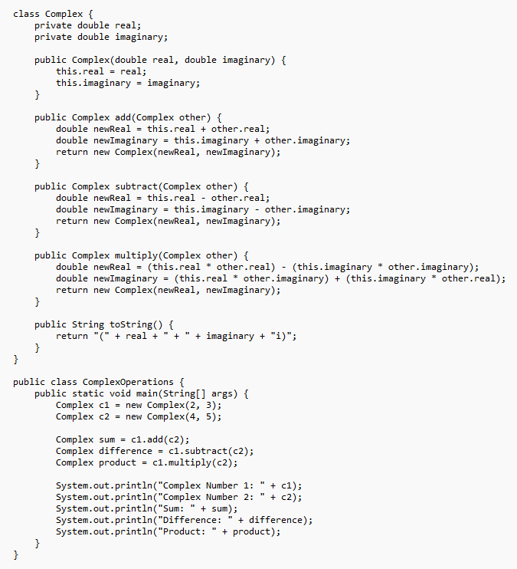

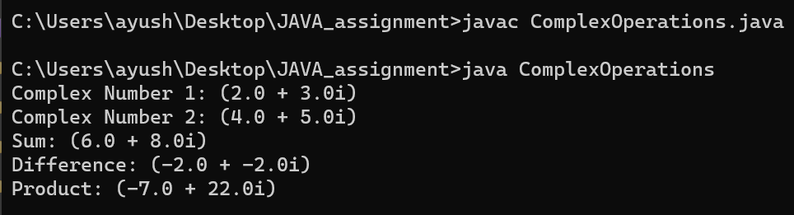

4. WAP to count the number of objects made of a particular class using static variable and static method to display the same.

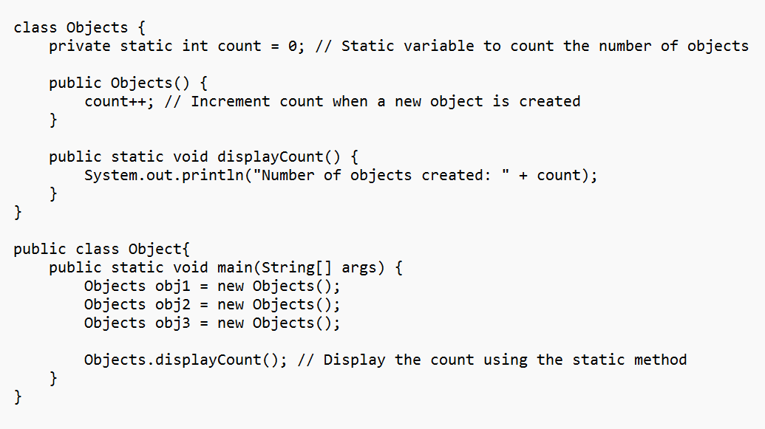

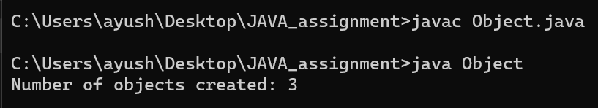

5. WOOP to arrange the names of students in descending order of their total marks, input data consists of students details such as names, ID.no, marks of maths, physics, chemistry. (Use array of objects)

